3rd Year Final Year Project

Louise Corbally – G00313361@gmit.ie

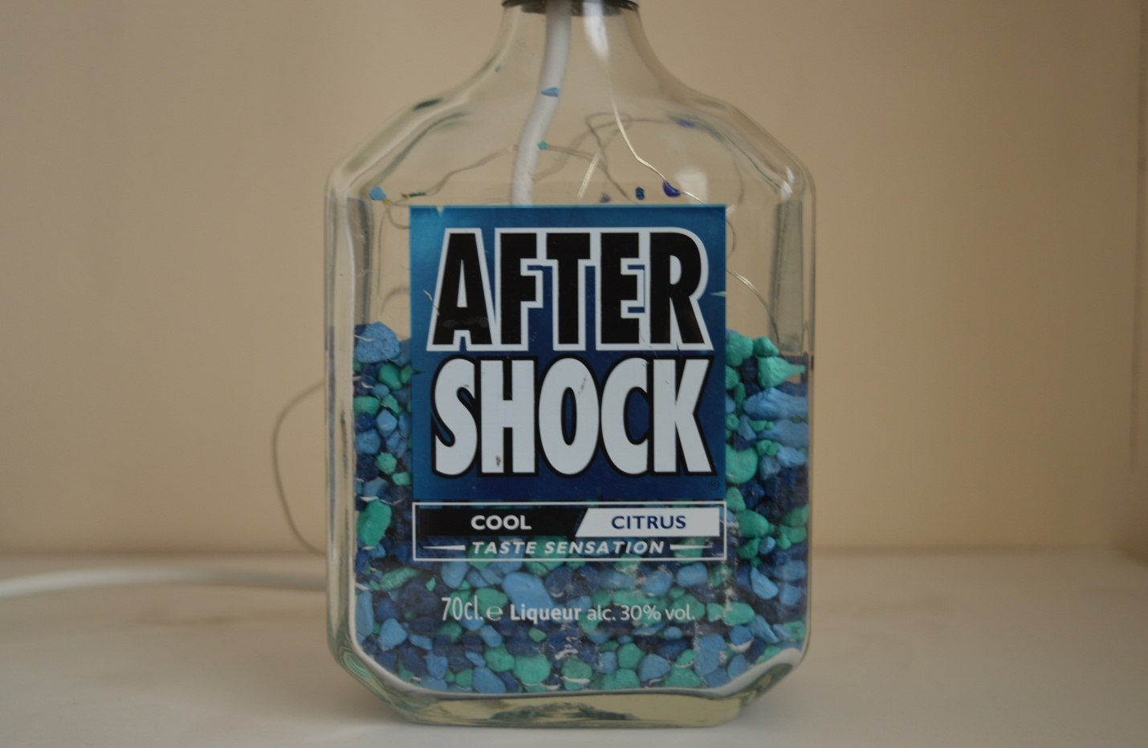

# Concept

The Lamp Genie was created to host a shopping website for my client, a local craftsman. It includes features to add items to a cart and pay with Paypal. My aim for the website was to showcase his work and be able to purchase products online. The products that are stocked on the website are bottle lamps, which essentially are lamps that can be made from any bottle of the customers choosing.

Table of Contents

1. Purpose of the website
   1. Design
      1. Content Flow Chart & Wireframe
   2. Page Content & Layout
2. Technical Specs
3. Project Plan
   1. Problems Incurred
4. Summary of Project
5. References

## Purpose of Website

The Lamp Genie was created by a local craftsman in 2017, however the company never had a website to advertise their products. When I met with the client they informed me that they would like their website to be simple, yet showcase their best work. From this I planned out what I was going to create for the client, I wanted something that would really bring attention to the products and the hard work that was put into the lamps. I created a website that was easy to navigate, where the consumer could view and purchase products.

## 1.1 Design

For the design on the website I went with a simple, easy to use layout. A navigation bar on the top of the screen with four tabs that when clicked will bring the user to individual pages. As well as having a home tab, if the user clicks the logo at the top left of the screen it will re-direct them back to the home page no matter where they are on the website.

For the color selection on the website I went with a more monotone look and feel. I decided that sticking with white and black while adding a pop of blue would work best. I took the inspiration for the blue from one of the lamps that the company has. I wanted the shop and contact page to use white space mostly, in the shop I again added a pop of blue to the cart.

Taking the use of white space into consideration gives the websites more of a fresh, modern feel which I believe is important when trying to build a reliable client base.

For the font and text of the website I originally was going to go with Verdana but after using it for a while I decided to go with Open Sans – Sans Serif. It is simple to read and timeless. For the about page and description of items I went choose to use lowercase as I didn’t want the text to feel as though it was being shouted at the user, however I went with uppercase for heading and product names.

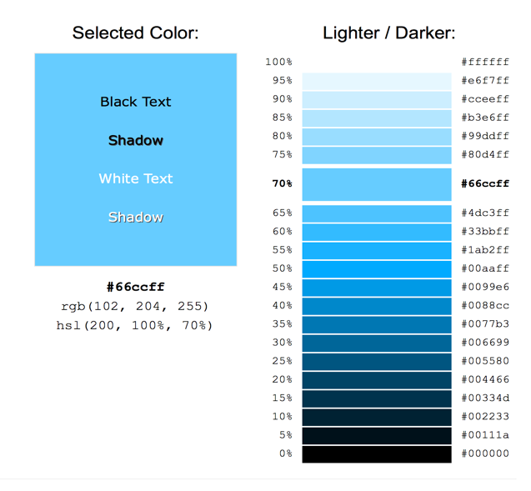

## 1.2 Page Content and Layout

As stated above the website consists of four pages. Each page contains the same header and footer.

A home page which essentially is a gallery page showing images that the store stocks. It includes a slide show with images of the products.

A product page where the user can purchase items, once the user select their item and the quantity it will proceed to take them to a shopping cart where they must enter their billing and shipping information, once they information is entered they can then proceed to checkout and pay using Paypal.

A contact pages which has the contact information of the store owner, a Google API map which shows the exact location and a form which the user can fill out, it prompts the user for their name, e-mail and contact number and their query, when the user submits the form, the enquiry is then sent to the database. The enquiry will then be stored there for future use and can be delete at any time.

An about page while goes into detail about the company and how it was set up. The about page includes a frequently asked section of questions that the client provided me with, these are questions that the client get asked quiet a lot and he would like to have them featured on the website. This section will save customers having to contact the client in order to find out a question that may have already been asked previously.

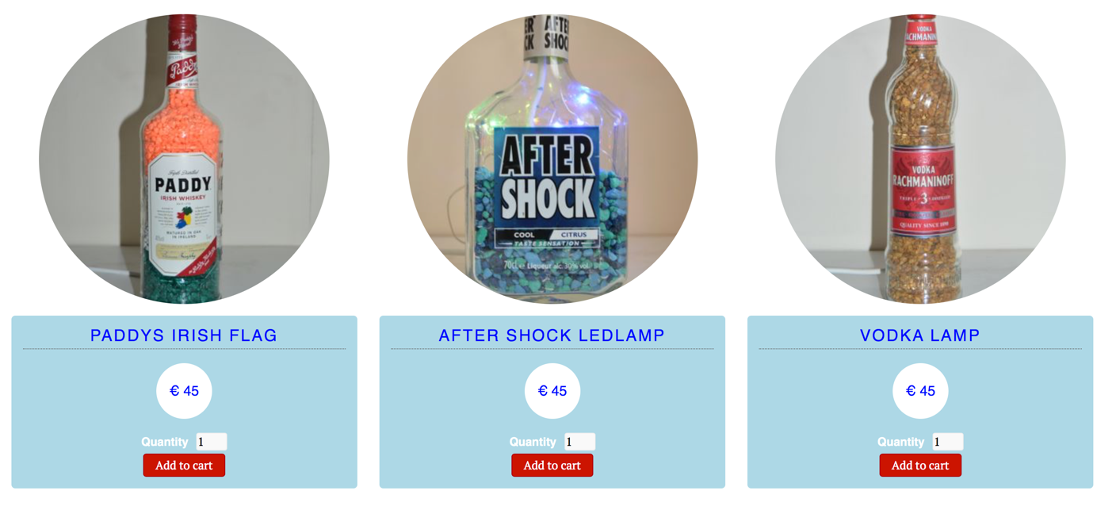

Cart

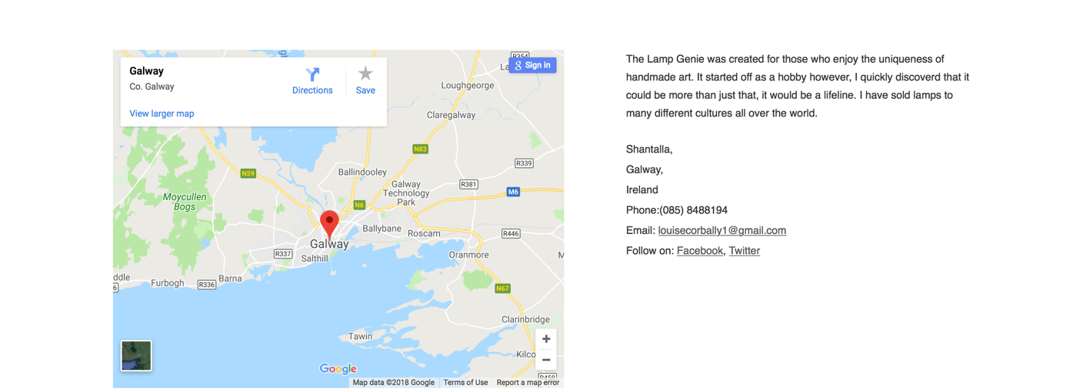

Contact Page

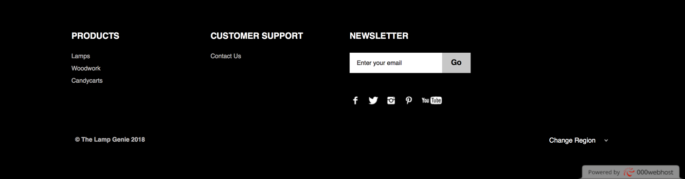

Footer



Nav Bar

1.1.1 Content Flow Chart & Wireframe

I created a content flow chart and a wireframe to give the client an initially idea as to what the website was going to look like at the beginning. However, once I started to create the website I realized that what I had initially thought was going to be the design ending up not working out how I wanted it to. I then re-created the content flow chart and wireframe, got the clients approval and set out creating the website again. Below you can see the before and after of the content flowchart and the wireframe of the main home page.

# 

Content Flow Chart

The only difference in this content flow chart and the finished website is that I did not include a product video on the gallery page of the product being made and the about page does not currently include customer reviews as of right now until more products start being sold.

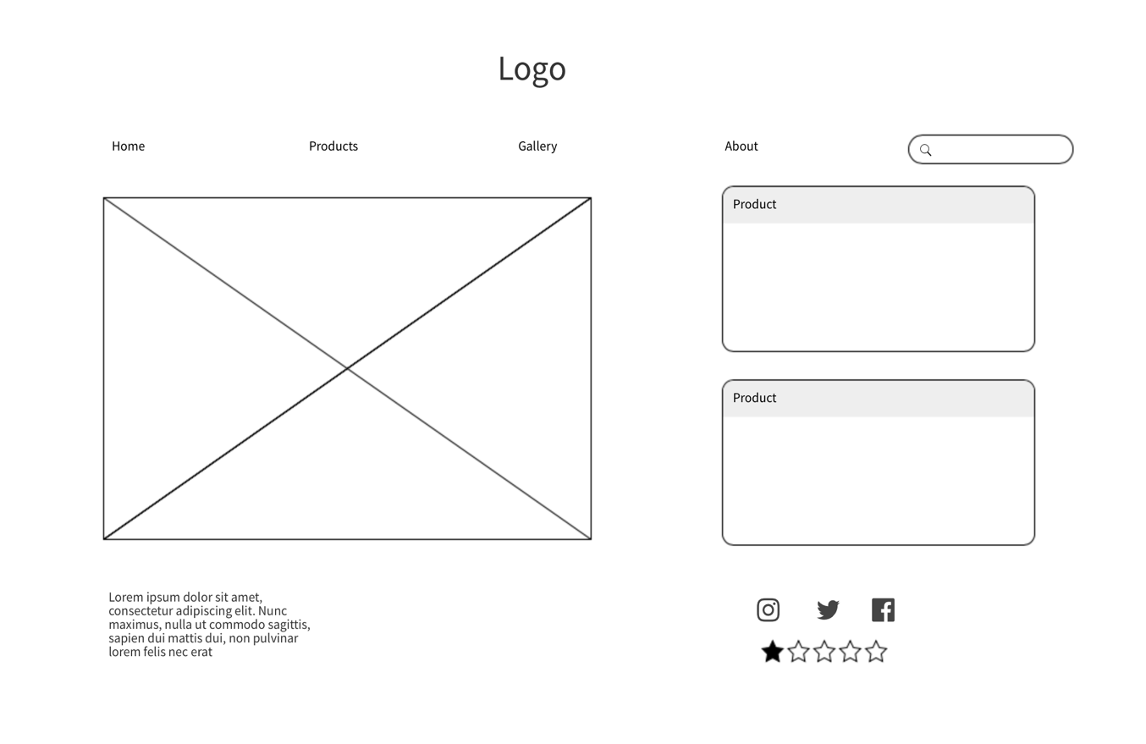

Before Wireframe

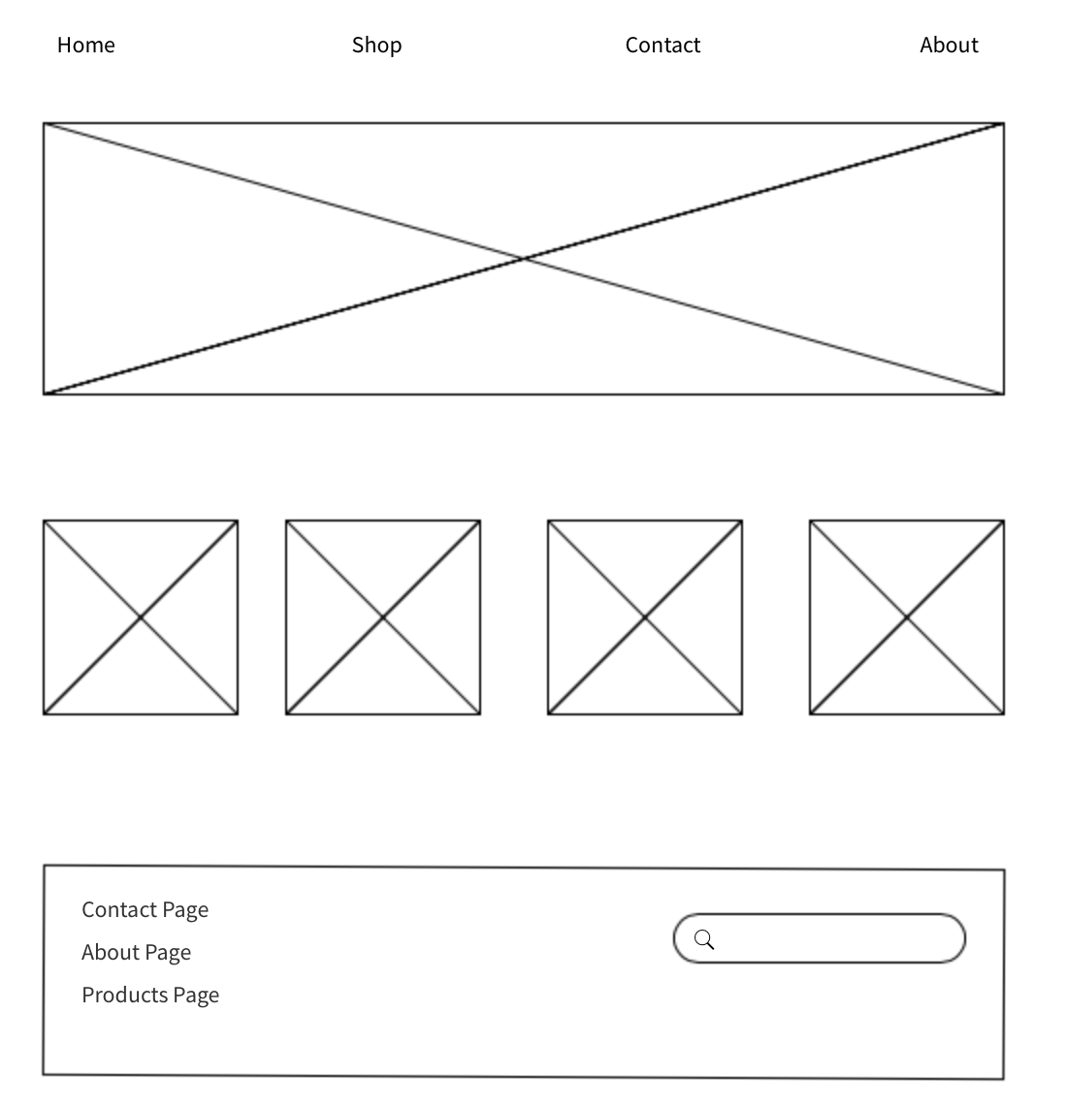

# 2.0 Technical Specs

Regarding code and languages used for this website I have incorporated a mix of different languages. Throughout the entire website there is consistent HTML5, CSS and JavaScript. The form and database was created using PHP.

List of programming languages used:

* HTML5
* CSS
* JavaScript
* Bootstrap
* PHP

For tools and equipment, I used a range of different applications. I used Visual Studio Code to write up the website, Adobe Photoshop and Illustrator to create and edit the logo. The images for the site where taken on a Nikon D3200 DSLR camera using soft box lighting and a tripod. I again used Adobe Photoshop to edit the photos for the site by adjusting the brightness. The imagery used in the website is all original, it was either taken or created by me and edited in Photoshop. I hosted the final website on 000webhost.com, this allowed me to host my database direct from the website also.

List of tools and equipment used:

* Visual Studio Code
* Adobe Photoshop
* Adobe Illustrator
* 000webhost.com
* Nikon D3200 DSLR Camera
* Softbox Lighting
* Tripod
* Macbook Pro

# 3.0 Project Plan

* Meet with client – discuss ideas & specs
* Brainstorm – mind map
* Design content flow chart
* Take & edit photos
* Create Logo
* Begin coding – basic elements
* Prototype demo – 20th February
* Start more in-depth programming
* Create database
* Insert cart
* Link Google API
* Add images to website
* Link the site to social media
* Meet with client again – show them the website
* Implement any changes the client would like
* Add finishing touches
* Test website and ensure all feature are working & no errors
* Host website

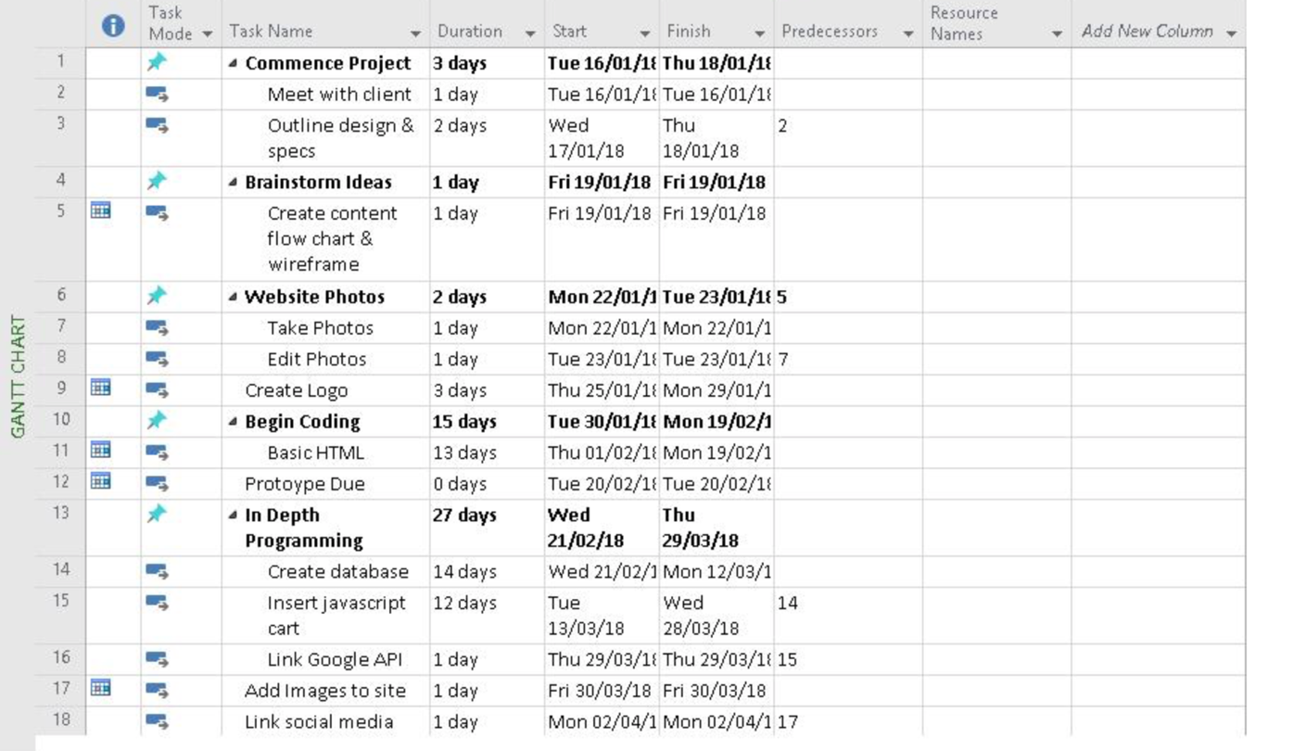

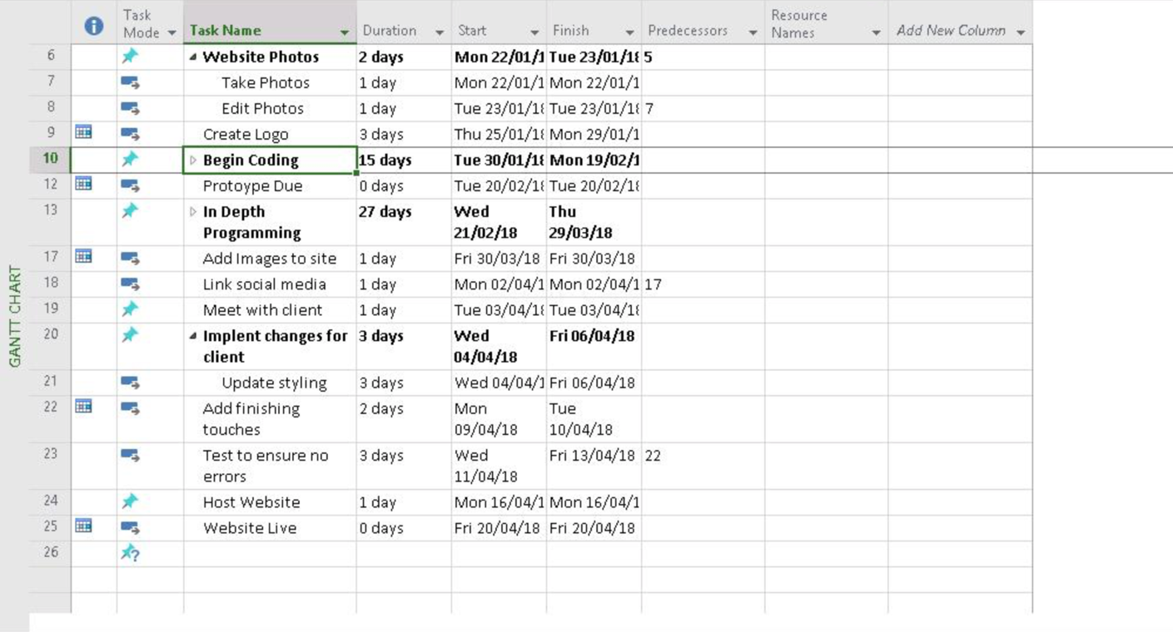

# 3.1 Problems Incurred

During creation of this website I incurred some issues in certain areas.

Creating the Database

Initially I had created the database using phpMyAdmin on my localhost, I imported the database and had a working form that sent the information to the database, however, once I hosted the website the database no longer worked, I encounter numerous errors that the webhost server could not reach the database. After numerous times of editing the database and deleting the file I discovered the issue. PhpMyAdmin cannot be accessed by a webhost, therefore I needed to re-create the database on the webhost site, once I did that and changed my code around to suit it, the database and form worked perfectly together.

CSS whilst hosting

Another issue I incurred after hosting the website was that my css and images were not loading. The content of the website was showing perfectly but the design was completely gone. I knew the images worked as I could see them when I loaded the website locally. Again, after deleting the files and re-uploading the issue was not resolved, out of chance I then noticed that my images were saved as .JPG however in my code I had it written as .jpg while upper and lower case is not an issue when hosting locally, it appears to be an issue when hosting from a webserver, after I fixed that my images and css files loaded again.

# 4.0 Summary

The creation of this website thought me several things, it showed me that in order to create a fully functional website it is necessary to put a lot of time an effort into it. I also noticed that sometimes what I thought would work best of the site, the client didn’t agree on and vice versa, I think that shows it’s important to always get a second opinion when it comes to design.

If I was to do this project again I would have done some things different, I would have used Google Jot form instead of using the PhpmyAdmin database to store the form inputs, however for the purpose of this project I needed to have a working database. If I had used Google Jot Form the client would be able to get the queries saved directly to an excel sheet instead of the database, it would also have mean the client would have been notified by email whenever a form was submitted.

# 5.0 References:

* [www.w3schools.com](http://www.w3schools.com)
* [www.bootstrap.com](http://www.bootstrap.com)
* [www.phpnet.com](http://www.phpnet.com)
* [www.mockflow.com](http://www.mockflow.com)
* [www.draw.io](http://www.draw.io)